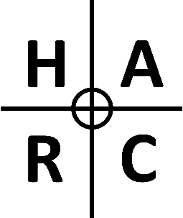

HAMBLETON ATHLETICS & RUNNING CLUB
ANNUAL GENERAL MEETING
7th MARCH 2022, 7pm @ The Buck Inn, Thornton Watlass

AGENDA
- Welcome and Introduction from Club Chair
- Report from Club Chair
- Report from Club Coach
- Report from Club Treasurer
- Report from Club Membership Secretary
- Election of Committee Members for 2022/23
- AOB (items must be notified to Secretary in advance)

